[MyEducator Home Page](https://www.myeducator.com/)

* [BMIS 441 02: Database Manag...](https://app.myeducator.com/course/activity/617eba/2701101307807948801/#)
* [Contents](https://app.myeducator.com/course/activity/617eba/2701101307807948801/#)
* Course
* Nathan Yoon

# **BMIS 441 02: Database Management [Fall 2021]**

## **SQL Assignment #8-Simple Queries**

For each information request below, formulate a single SQL query to produce the required information. In each case, you should display only the columns requested. Be sure that your queries do not produce duplicate records unless otherwise directed.

| Due Date: | Oct 24 at 23:59 |
| --- | --- |
| Points: | 100 |

Graded on Oct 28 at 22:02

Your Submission:

| Submission Score: | 100 / 100 (100.00%) |
| --- | --- |
| Grade Time: | Oct 28 at 22:02 |
| Submitted On: | Oct 21 at 11:48 |

*Feedback on this submission:* Perfect!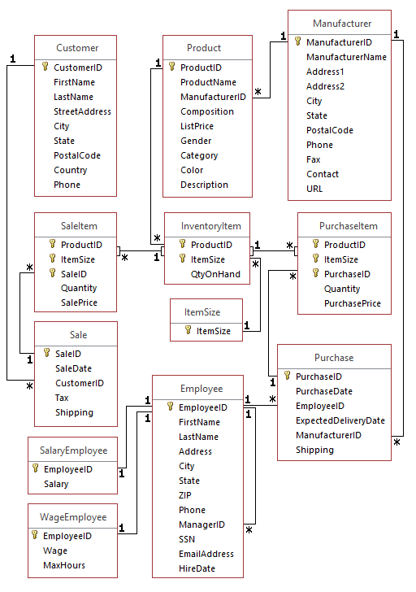

1. List SaleDate and the sum of tax and shipping for each sale from 2015-12-20 through 2015-12-25. (use BETWEEN. Name the calculated column SUM)  
   NOTE: Due to an anomaly within MySQL for numeric fields, sometimes calculated results have 14 decimal places and inexact amounts. To ensure your answer is correct use the ROUND function to two decimal places, i.e. ROUND(Tax+Shipping,2)
2. SELECT SaleDate, ROUND((Tax + Shipping),2) AS 'SUM'
3. FROM Sale
4. WHERE SaleDate BETWEEN '2015-12-20'
5. AND '2015-12-25';

**FEEDBACK**10 / 10 (100.0%)

1. List the data in the Salaried Employees table about Salaried Employees earning between $40000 and $50000. (use between)
2. SELECT *
3. FROM SalaryEmployee
4. WHERE Salary BETWEEN 40000
5. AND 50000;

**FEEDBACK**10 / 10 (100.0%)

1. Give Customer IDs and cities for customers who are located in Chicago, Saint Louis, Baltimore, or Newark. (Use the IN operator.)
2. SELECT CustomerID, City
3. FROM Customer
4. WHERE City IN ('Chicago', 'Saint Louis', 'Baltimore', 'Newark');

**FEEDBACK**10 / 10 (100.0%)

1. What is the customerID for Sam Gill?
2. SELECT CustomerID
3. FROM Customer
4. WHERE FirstName = 'Sam'
5. AND LastName = 'Gill';

**FEEDBACK**10 / 10 (100.0%)

1. Give the sales data for sales where sales tax was charged (not equal to 0) and total of tax and shipping is less than $15. (use the NOT operation.) Show all sales data.
2. SELECT *
3. FROM Sale
4. WHERE NOT Tax = 0
5. AND (Tax + Shipping) < 15;

**FEEDBACK**10 / 10 (100.0%)

1. Create an alphabetical list of names (first and last, alphabetized by last) of customers in Minnesota (MN).
2. SELECT FirstName, LastName
3. FROM Customer
4. WHERE State = 'MN'
5. ORDER BY LastName ASC;

**FEEDBACK**10 / 10 (100.0%)

1. Give names of manufacturers and their cities that are located in cities with names ending with 'City'.
2. SELECT ManufacturerName, City
3. FROM Manufacturer
4. WHERE City LIKE '%City';

**FEEDBACK**10 / 10 (100.0%)

1. List the information of each sale item where 2 or more items were sold but only for sizes 5, 6, and 7 (Use the keyword IN.) Show all sale item information.
2. SELECT *
3. FROM SaleItem
4. WHERE Quantity >= 2 AND ItemSize IN (5,6,7);

**FEEDBACK**10 / 10 (100.0%)

1. List Employee names (first and last) of employees who manage themselves (EmployeeID = ManagerID) or have a null value as the manager id.
2. SELECT FirstName, LastName
3. FROM Employee
4. WHERE EmployeeID = ManagerID OR ManagerID IS NULL;

**FEEDBACK**10 / 10 (100.0%)

1. Give full names of customers that have a 'D' as the third character in their last names. Eliminate duplicates.
2. SELECT DISTINCT FirstName, LastName
3. FROM Customer
4. WHERE LastName LIKE '__d%';

**FEEDBACK**10 / 10 (100.0%)

Copyright © 2022 MyEducator. All rights reserved.

[Need Help?](https://myeducator.freshdesk.com/support/home)